IT DEPARTMENT MANAGEMENT SYSTEM

Submitted in partial fulfillment of the requirements of the Degree
BACHELOR OF ENGINEERING IN INFORMATION TECHNOLOGY
By

Girish Mahajan Roll no:-19

Harshad Salunke Roll no:-27

Hemangi Thoke Roll no:-36

Supervisor
Prof. Prajkta Khaire



Department of Information Technology

Shivajirao S. Jondhale College of Engineering.

Dombivli (E)

(Affiliated to University of Mumbai)

(AY 2025-26)

CERTIFICATE

This is to certify that the Mini Project entitled“IT Department Management System” is abonafidework of Girish Mahajan (19), Harshad Salunke (27), Hemangi Thoke (36) submitted to the University of Mumbai in partial fulfilment of the requirement for the award of the degree of “Bachelor of Engineering” in “Information Technology” .

(Prof. Prajkta Khaire) (Prof. Deepali Narkhede)
Supervisor Project Coordinator

(Dr. Savita Sangam) (Dr.Uttara Gogate)
Head of Department Principal

Internal Examiner External Examiner

Mini Project Approval

This Mini Projectentitled““IT Department management system” by is Girish Mahajan(19), Harshad Salunke(27), Hemangi Thoke(36) approved for the degree of Bachelor of Engineering in Information Technology.

Examiners

1………………………………………
(Internal Examiner Name &Sign)

2…………………………………………
(External Examiner name &Sign)

Date: Place:

TABLE OF CONTENT

SR NO. | TITLE | PAGE NO.
 | ABSTRACT | ii
 | ACKNOWLEDGMENTS | iii
 | LIST OF FIGURES | iv
1 | INTRODUCTION | 1
1.1 | Introduction | 2
1.2 | Motivation | 3
1.3 | Problem Statement & Objectives | 5
1.4 | Organization of the Report | 8
2 | LITERATURE SURVEY | 11
2.1 | Survey of Existing System | 12
2.2 | Limitation Existing system or research gap | 14
3 | PROPOSED SYSTEM | 16
3.1 | Introduction | 17
3.2 | Architecture/ Framework | 18
3.3 | Algorithm and Process Design | 20
3.4 | Details of Hardware & Software | 22
3.5 | Experiment and Results | 24
3.6 | Conclusion and Future work | 26
 | REFERENCES | v

ABSTRACT

In today’s digital era, the effective management of Information Technology (IT) resources is critical for the smooth functioning of organizations. Many institutions, including educational organizations, small businesses, and corporate departments, face significant challenges in managing hardware, software, employee records, projects, and technical support tasks using traditional manual methods. Manual processes often lead to data redundancy, errors, delayed problem-solving, and inefficiencies.

The Information Technology Management System (ITMS) is a web-based solution designed to address these challenges by providing a centralized, automated, and secure platform for managing all IT-related operations. The proposed system integrates multiple functionalities into a single platform, including Asset Management, Employee Management, Project Tracking, Helpdesk/Support Ticket Management, and Report Generation. This integration ensures seamless coordination between IT staff, administrators, and other organizational members.

The Asset Management module tracks the lifecycle of all hardware and software, including procurement details, warranties, usage, and maintenance schedules. The Employee Management module maintains detailed profiles and role-based access to safeguard sensitive information. The Project Tracking module allows admins to assign tasks, monitor progress, and generate project performance reports. The Helpdesk module enables employees to submit technical issues or requests, while admins or IT staff can efficiently track and resolve them. Additionally, the Report Generation module provides real-time analytical insights, aiding management in decision-making and resource optimization.

The system is developed using HTML, CSS, JavaScript for the backend processing, and MySQL as the database. This technology stack ensures a responsive, user-friendly interface and efficient handling of data operations. Role-based authentication and secure session management protect sensitive organizational data, while automated backups prevent data loss.

By automating routine tasks and centralizing IT management, the ITMS significantly reduces manual effort, enhances operational efficiency, improves communication, and ensures timely problem resolution. Furthermore, the system is scalable, cost-effective, and flexible, allowing future expansions such as advanced reporting, mobile accessibility, or additional workflow modules.

ACKNOWLEDGMENT

The satisfaction that accompanies the successful completion of any task would be incomplete without the mention of people whose ceaseless cooperation made it possible, who‟s constant guidance and encouragement crown all efforts with success. We feel pleasure and thankful in expressing our heartfelt gratitude and vote of thanks to over guide prof. Prajkta Khaire who guided us in difficult situations and helped us to enhance the concept of our mini project.
We would also like to thank our respected Principal Dr.Uttara Gogate and our Head Of Department Dr. Savita Sangam for allowing and suggested us to build and present this mini project.

By

Girish Mahajan(19)

Harshad Salunke(27)

Hemangi Thoke(36)

CHAPTER: - 1. INTRODCTION

INTRODCTION:

The Information Technology Management System (ITMS) is a comprehensive web-based or desktop application designed to manage and streamline the operations of an IT department efficiently. It provides an organized platform for handling the key functions such as employee management, project tracking, asset management, technical support, and data maintenance. The system ensures smooth coordination between administrators, staff, and users, thereby improving productivity and service quality.

In today’s digital era, every organization relies heavily on IT resources like computers, networks, and software systems. Managing these resources manually becomes time-consuming and prone to errors. The IT Management System automates these tasks by maintaining records, monitoring performance, scheduling maintenance, and generating reports in real time. It also supports data security, ensuring that sensitive organizational information remains protected from unauthorized access.

This project aims to create a centralized system that simplifies the management of IT infrastructure within an organization. It allows the admin to add or remove users, allocate assets, track project progress, monitor network issues, and provide support services through a single dashboard. Employees can also log in to view assigned tasks, request technical assistance, or update project statuses.

By implementing this system, organizations can achieve:

Better Resource Utilization: Optimizes hardware, software, and manpower usage.

Faster Decision-Making: Real-time analytics and reporting help in data-driven decisions.

Improved Communication: Enhances coordination between IT staff and other departments.

Reduced Paperwork: All records are stored digitally for easy retrieval and maintenance.

Enhanced Security: Controlled access and backup features protect critical data.

  - MOTIVATION:-

In the modern world, Information Technology (IT) plays a vital role in every organization. Almost all departments in businesses, colleges, and government institutions depend on IT systems for smooth and efficient functioning. However, managing IT resources such as computers, software, networks, and user support manually often leads to inefficiency, data loss, and delays. This problem inspired the idea of developing an Information Technology Management System (ITMS) that can automate and simplify all IT-related tasks in a single platform.

The main motivation behind creating this project is to eliminate the challenges of manual record-keeping and improve the overall efficiency of IT operations. In many organizations, tracking hardware assets, maintaining software licenses, managing employee information, and handling support requests are done through spreadsheets or paper records. This process is time-consuming, error-prone, and difficult to update. Therefore, a need arises for a system that can manage all this data digitally in an organized, secure, and user-friendly way.

Another key motivation is the increasing demand for centralized IT management in organizations that are rapidly adopting technology. As the number of systems, networks, and users grows, it becomes difficult for the IT department to maintain control and ensure data security. The IT Management System provides a solution by offering features like role-based access, real-time monitoring, data backup, and report generation, making management easier and more transparent.

From a student and developer perspective, this project also serves as a great opportunity to gain practical experience in building real-world applications using technologies such as HTML, CSS, JavaScript, PHP, and MySQL. It encourages innovation and problem-solving by applying software development principles to address real organizational challenges.

Key Motivational Factors

- Automation of Manual Work: To reduce human errors and save time by automating repetitive IT management tasks.

- Centralized Management: To store and access all IT-related data (assets, employees, projects, etc.) from a single system.

- Efficiency and Productivity: To increase the overall efficiency of IT departments and improve response time to issues.

- Data Security: To protect important information through authentication and secure data handling.

- Real-Time Monitoring and Reports: To help administrators make better and faster decisions using accurate data.

- Learning and Skill Development: To gain hands-on experience in database management, web development, and system design.

1.3 PROBLEM SATATEMENT AND OBJECTIVE:-

- Problem statement:-

In today’s digital era, every organization relies heavily on Information Technology (IT) for managing its operations, communication, and data. However, in many institutions and companies, the management of IT resources and processes is still performed manually. This traditional method involves maintaining records on paper or in spreadsheets, which is time-consuming, error-prone, and inefficient.

Manual IT management leads to several key problems:

Difficulty in tracking hardware and software assets, including their usage, maintenance, and warranty details.

Poor coordination between IT staff, administrators, and employees, resulting in delayed problem-solving.

Lack of centralized data storage, making it hard to retrieve or update information quickly.

Inadequate security and access control, increasing the risk of data loss or misuse.

Absence of real-time monitoring and reporting, which affects decision-making and performance analysis.

Due to these challenges, organizations face reduced efficiency, data inconsistency, and high operational costs. Hence, there is a strong need for an automated IT Management System that can manage all these tasks through a single integrated platform.

The proposed Information Technology Management System (ITMS) aims to provide a centralized, secure, and user-friendly solution for managing IT resources, tracking projects, handling support requests, and generating analytical reports. It will help administrators monitor the entire IT infrastructure in real time, improve communication, and ensure smooth functioning of the IT department.

Objective:-

The main objective of the Information Technology Management System is to develop a digital platform that automates and simplifies the management of IT operations in an organization. The system aims to enhance efficiency, accuracy, and security while reducing manual effort and paperwork.
Specific Objectives:

To automate IT operations:
Replace manual record-keeping with an automated system to manage IT assets, employee data, and technical support tasks efficiently.

To create a centralized database:
Maintain all IT-related information (hardware, software, users, and projects) in a single database for easy access and updates.

To enhance communication and workflow:
Provide a platform that improves coordination between the IT team, administrators, and other departments through timely updates and notifications.

To ensure data accuracy and security:
Implement login authentication and role-based access to protect confidential information from unauthorized users.

To generate analytical reports:
Produce detailed reports on assets, employee performance, project status, and maintenance schedules to assist in better decision-making.

To provide user-friendly interfaces:
Design an easy-to-use dashboard for both admin and users to perform their tasks conveniently without technical difficulties.

To save time and reduce cost:
Reduce manual work, paperwork, and resource wastage by automating daily IT management activities.

To support scalability and future upgrades:
Build a flexible system that can be easily modified or expanded as organizational needs grow.

1.4 ORGANIZATION OF REPORT

Chapter 01:- Introduction, Motivation, Problem statement and objective.

Chapter 02:- literature survey of various phases of IT Department Mnagement system : Survey of existing system (IT Department Management System) Limitations of existing system or Research gap and mini project contribution.

Chapter 03:- Proposed system which states the Introduction, Architecture and Framework: which tells about flowcharts, Algorithm and process design: which tells about steps to be followed for budget execution, Details of hardware and software: which tells about requirement analysis for the system, Experiment and results: which tells about the IT Department management system project and show screenshots of the running game or project, and also the future scope is explained in that which has results and conclusion after studying proposed system.

CHAPTER: - 2. LITERATURE SURVEY

2.1 SURVEY OF EXISTING SYSTEM:-

Introduction

The existing IT Department Management Systems are designed to manage and automate various departmental activities such as faculty, student, and HOD information, asset tracking, timetable management, and complaint handling. Many institutions currently use different types of systems like helpdesk and ticketing systems, asset management software, and ERP-based campus solutions to handle IT-related operations. These systems provide features like service request tracking, hardware and software inventory management, user data storage, and report generation. Some systems also include modules for timetable scheduling, attendance, and communication between staff and students. Open-source systems are cost-effective and customizable, while commercial tools offer advanced features such as SLA tracking, analytics, and integration with external platforms. However, the existing systems have several limitations. Most of them work as isolated modules without proper integration, leading to data duplication and inefficiency. Many tools are difficult to customize according to an educational institution’s specific workflow and can be expensive to maintain. Data accuracy also becomes a challenge because asset and user records are not regularly updated. In addition, most systems lack automation features like auto ticket assignment, predictive maintenance, or AI-based reporting. Some have limited mobile support, making it difficult for on-site technicians to update information in real time. Security and privacy of data are also major concerns, as some systems do not provide strong authentication or access control features. Therefore, there is a need for a unified, user-friendly, and cost-effective IT Department Management System that can integrate all departmental functions—faculty, student, and HOD modules—into one platform with automation, real-time reporting, and secure data management.

LIMITATIONS EXISTING SYSTEM OR RESEARCH GAP:-

Although several Information Technology Management Systems (ITMS) and IT Service Management (ITSM) tools already exist, most of them face certain limitations that affect their performance, usability, and adoption — especially in educational institutions, small organizations, or resource-limited environments.
These limitations create a research gap and highlight the need for a new, simplified, and cost-effective system that can address real-world management challenges efficiently.

1. High Cost and Complexity
Most commercial IT management systems (like ServiceNow, ManageEngine, or SolarWinds) are designed for large enterprises.They require expensive licenses, advanced infrastructure, and technical expertise for installation and maintenance.Small or medium organizations often cannot afford these tools.The system interfaces are often complex, which makes them difficult for non-technical users to operate.
🔹 Research Gap: There is a need for a lightweight and affordable IT management system that provides essential features without the complexity of enterprise-level tools.

2. Lack of Customization and Flexibility
Many existing systems are built on fixed workflows and limited customization options.They do not easily adapt to the specific needs of schools, colleges, or small companies Custom modules (like lab asset management, IT request tracking, or project monitoring) often require extra development or plugins.
🔹 Research Gap: A flexible system that can be customized according to user roles and organizational needs is required.

3. Poor Integration Between Modules

In several systems, modules like asset management, employee tracking, and helpdesk are not fully integrated.Users have to manage multiple applications or switch between dashboards.This leads to data duplication, inconsistency, and inefficient reporting.
🔹 Research Gap: There is a need for a single integrated platform where all IT operations — from asset management to support — are connected seamlessly.

4. Limited User Accessibility and Interface Issues
Some older systems have outdated user interfaces and lack mobile or web accessibility.Users find it hard to navigate or perform basic operations.The absence of responsive design affects usability on smartphones and tablets.
🔹 Research Gap: Developing a modern, user-friendly, web-based interface using HTML, CSS, and JavaScript can improve user experience and accessibility.

5. Insufficient Real-Time Data and Reports
Existing manual or semi-automated systems do not provide real-time monitoring or analytical reports.Admins cannot quickly analyze IT usage, maintenance needs, or project progress.Delayed information affects decision-making and problem-solving.
🔹 Research Gap: A system that provides real-time updates, performance metrics, and auto-generated reports can help management take quicker and better decisions.

6. Security and Data Protection Issues
Manual systems or poorly designed software do not ensure proper data security.There is a risk of unauthorized access, data leaks, or accidental deletions.Backup and recovery mechanisms are often missing.
🔹 Research Gap: A system with role-based authentication, secure data storage, and automatic backups is needed to protect sensitive information.

CHAPTER: - 3.PROPOSED SYSTEM

  - Introduction

The proposed IT Department Management System is designed to overcome the limitations of the existing manual and semi-automated systems by providing a centralized, efficient, and user-friendly digital platform. This system integrates all essential departmental functions — such as faculty, student, and HOD management — into one web-based solution. The proposed system will allow smooth communication and coordination among all members of the IT department while maintaining accurate records of academic and technical activities.

The system will enable faculty members to update and access academic schedules, manage lab records, submit reports, and communicate with the HOD. Students can use the platform to view notices, submit complaints or requests related to IT infrastructure, and check lab schedules. The HOD will have administrative access to monitor faculty performance, handle student grievances, allocate tasks, and generate analytical reports for decision-making.

The system will include modules for complaint management, asset and equipment tracking, timetable scheduling, and attendance monitoring. A centralized database will store all departmental data securely, ensuring data consistency and quick retrieval when required. Role-based authentication will be implemented to maintain data security and privacy, ensuring that each user can only access information relevant to their role.

Additionally, the proposed system will feature an intuitive web-based interface built using HTML, CSS, and JavaScript, making it accessible through any device with an internet connection. Future integration with cloud storage and mobile applications can further enhance accessibility. The system will also support automated report generation, which helps in tracking departmental activities, equipment usage, and maintenance requirements efficiently.

Overall, the proposed IT Department Management System aims to digitize and automate departmental operations, reduce paperwork, improve communication between faculty, students, and HOD, and promote a more transparent, efficient, and well-organized environment within the IT department.

Architecture/ Framework

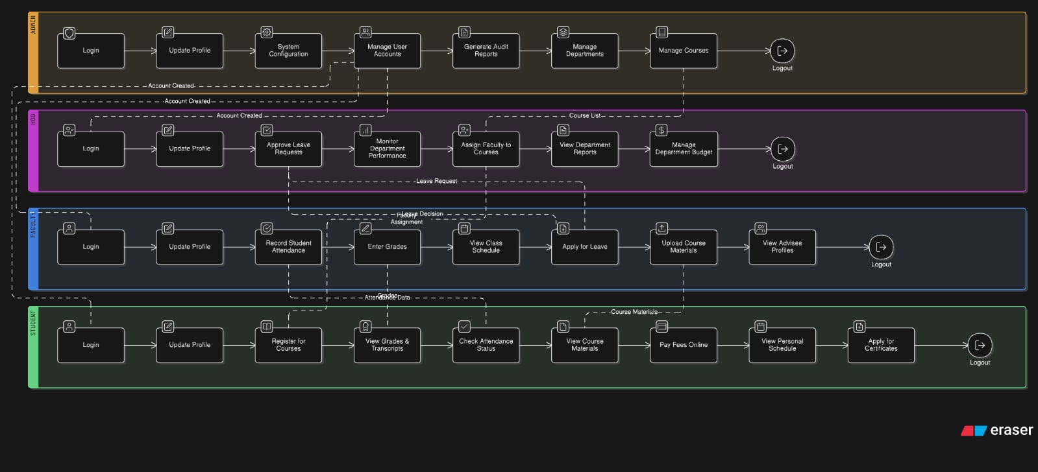

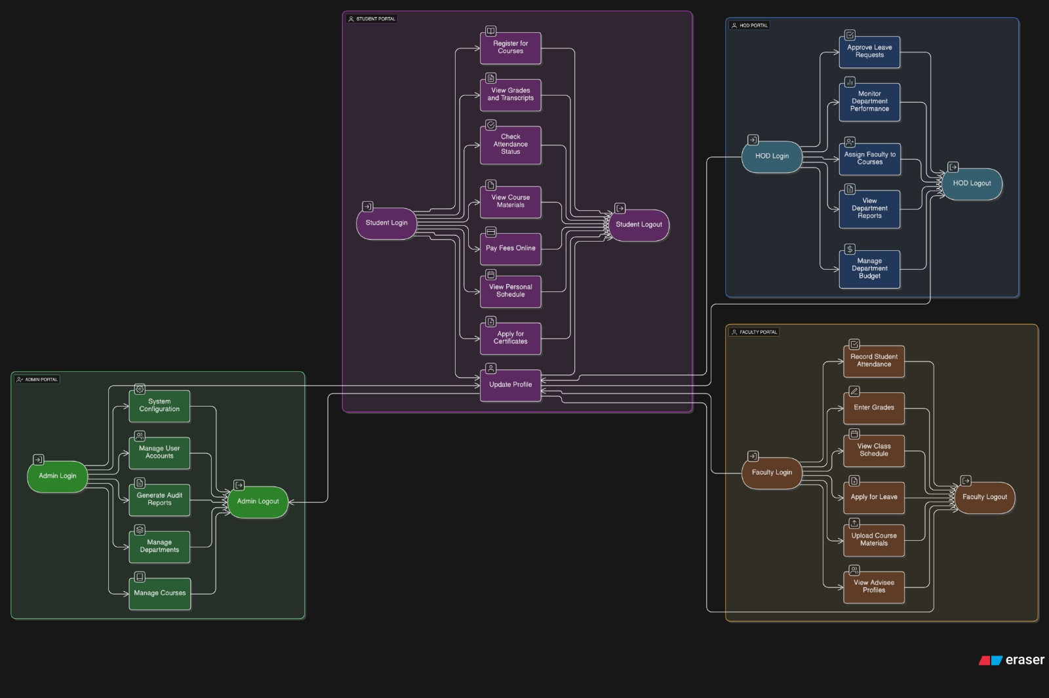

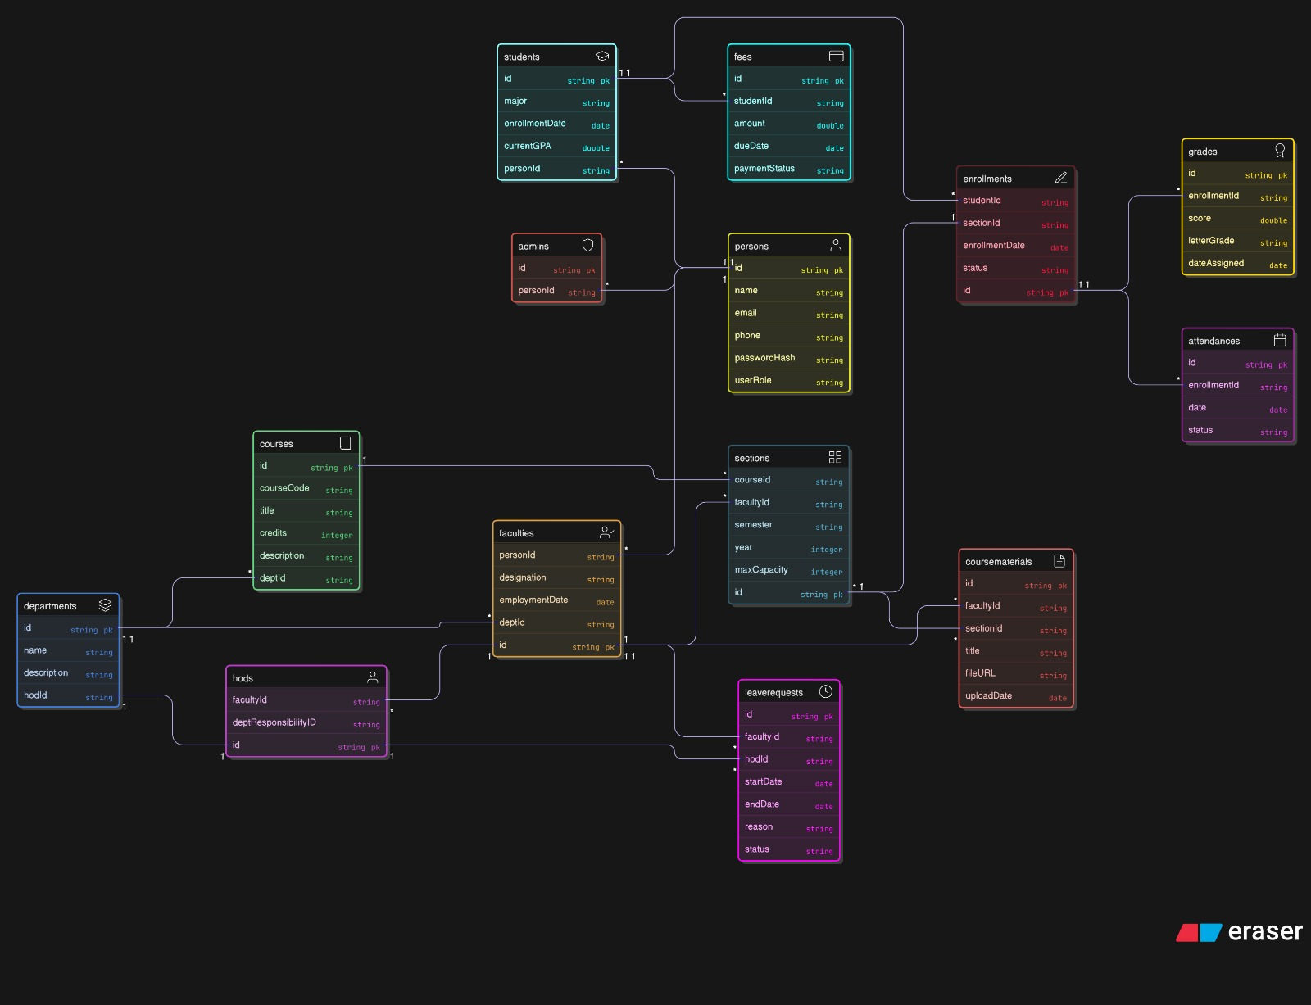

Algorithm and Process Design

The algorithm and process design describe the logical flow and step-by-step operations of the IT Department Management System. It defines how data moves between users (Faculty, Students, and HOD) and how various modules such as login, complaint management, timetable, and asset tracking function together to achieve automation and efficiency within the department.

2. System Modules and Workflow
The system is divided into several interconnected modules:

User Authentication Module – Handles secure login and registration for students,faculty, and HOD

Dashboard Module – Displays role-based dashboards with relevant options and data.

Complaint Management Module – Allows students to submit issues, faculty or technicians to resolve them, and HOD to monitor progress.

Asset Management Module – Tracks IT equipment, lab assets, and their maintenance status.

Timetable Management Module – Manages class and lab schedules for faculty and students.

Report Generation Module – Generates summaries for HOD review and decision-making.

3. General Algorithm (Main Flow)
Step 1: Start the system and display the home page.
Step 2: User selects their role (Student / Faculty / HOD).
Step 3: User enters login credentials (ID and password).
Step 4: System verifies credentials from the database.
• If valid → proceed to respective dashboard.
• If invalid → show an error message and prompt retry.
Step 5: Based on the role, display the respective module options:
- Student: Submit complaint, view timetable, check status.
- Faculty: Update timetable, manage lab data, view student issues.
- HOD: Review reports, monitor complaints, assign tasks.
Step 6: Perform the requested operation (e.g., submit complaint, generate report).
Step 7: Update the database with new information (complaint status, timetable update, etc.).
Step 8: Generate confirmation or display updated data to the user.
Step 9: End or log out of the system.

4. Complaint Management Algorithm
Step 1: Student logs into the system.
Step 2: Selects “Register Complaint.”
Step 3: Enters details (issue type, description, lab number, etc.).
Step 4: System stores complaint in the database with a unique ID and status “Pending.”
Step 5: Faculty/HOD reviews complaints from the dashboard.
Step 6: Assigns the issue to a technician or resolves it directly.
Step 7: Once resolved, status changes to “Completed.”
Step 8: Student can view the updated status in their portal.

5. Timetable Management Algorithm
Step 1: Faculty logs in and opens the “Timetable Management” module.
Step 2: Enters or updates subject, time slot, lab/classroom number.
Step 3: System checks for scheduling conflicts.
Step 4: If conflict found → prompt for correction.
Step 5: If no conflict → save timetable in database.
Step 6: Students can view their updated timetable on their dashboard.

6. Report Generation Process
Step 1: HOD selects “Generate Report” from dashboard.
Step 2: System retrieves data (complaints handled, faculty performance, lab utilization).
Step 3: Data is processed and summarized into tabular or graphical format.
Step 4: Report is displayed or exported for record-keeping.

7. Process Design Overview
The process design is built on modular architecture, ensuring that each component (login, complaint, timetable, asset tracking) functions independently but shares a common centralized database.
Each user interacts through a simple web interface where operations are handled via form submissions, database queries, and role-based access control.

Key design features:

Secure user authentication using hashed passwords.

Central database connectivity using SQL/NoSQL structure.

Real-time updates and notifications.

Scalable and modular process flow.

Clear data validation and error-handling routines

Details of Hardware & Software

Hardware:-

- Processor “ Intel Core i7 hp

- RAM 8GB

- Hard disk 1TB

- Operating system: windows 10

Software:-

- VS CODE

Experiment and Results

Concepts used:

- HTML
- CSS
- JAVASCRIPT

Project Implementation:

Code:
import { renderLoginScreen } from './components/LoginScreen.js';
import { renderDashboardLayout } from './components/DashboardLayout.js';
import { UserRole } from './types.js';
import { loadState, saveState } from './state.js';

export default function App(rootElement) {
const state = loadState();

function render() {
if (!state.user) {
renderLoginScreen(rootElement, {
onLogin: actions.login,
});
} else {
renderDashboardLayout(rootElement, { ...state, ...actions });
}
}

const actions = {
login: (role) => {
if ((role === UserRole.Faculty || role === UserRole.HOD) && state.faculty.length === 0) {
alert('No faculty members have been configured in the system.');
return;
}
if (role === UserRole.Student && state.students.length === 0) {
alert('No students have been configured in the system.');
return;
}

let userToLogin;

if (role === UserRole.HOD) {
// Find the designated HOD user.
userToLogin = state.faculty.find(f => f.role === UserRole.HOD);
} else if (role === UserRole.Faculty) {
// Find the first non-HOD faculty member to act as the default faculty login.
userToLogin = state.faculty.find(f => f.role === UserRole.Faculty);
} else if (role === UserRole.Student) {
// Use the first student in the list as the default student login.
userToLogin = state.students[0];
}

if (userToLogin) {
// Assign the complete user object to the state.
state.user = userToLogin;
state.activeComponent = 'Dashboard';
render();
} else {
alert(Cannot log in. A default user for the '${role}' role could not be found. Please check the system's initial data.);
}
},
logout: () => {
state.user = null;
render();
},
setActiveComponent: (componentName) => {
state.activeComponent = componentName;
render();
},
addStudent: (newStudent) => {
state.students.push({
...newStudent,
id: S${(state.students.length + 1).toString().padStart(3, '0')},
attendance: 100,
subjectMarks: {}
});
saveState(state);
alert('Student added successfully!');
render();
},
removeStudents: (studentIds) => {
const initialCount = state.students.length;
state.students = state.students.filter(student => !studentIds.includes(student.id));
const removedCount = initialCount - state.students.length;

if (removedCount > 0) {
saveState(state);
alert(${removedCount} student(s) removed successfully!);
}
render();
},
updateMarks: (updates) => {
let updatedCount = 0;
updates.forEach(({ studentId, courseCode, markType, value }) => {
const student = state.students.find(s => s.id === studentId);
if (student) {
if (!student.subjectMarks[courseCode]) {
student.subjectMarks[courseCode] = {};
}
// Handle empty string from input to remove the mark
if (value === null || isNaN(value)) {
delete student.subjectMarks[courseCode][markType];
} else {
student.subjectMarks[courseCode][markType] = value;
}
updatedCount++;
}
});

if (updatedCount > 0) {
saveState(state);
alert(${updates.length} mark(s) updated successfully!);
}
render();
},
addFaculty: (newFaculty) => {
state.faculty.push({
...newFaculty,
id: F${(state.faculty.length + 1).toString().padStart(3, '0')},
role: UserRole.Faculty,
});
saveState(state);
alert('Faculty added successfully!');
render();
},
removeFaculty: (facultyIds) => {
const initialCount = state.faculty.length;
state.faculty = state.faculty.filter(f => !facultyIds.includes(f.id));
const removedCount = initialCount - state.faculty.length;

if (removedCount > 0) {
saveState(state);
alert(${removedCount} faculty member(s) removed successfully!);
}
render();
},
updateFaculty: (facultyId, updatedData) => {
const facultyIndex = state.faculty.findIndex(f => f.id === facultyId);
if (facultyIndex !== -1) {
state.faculty[facultyIndex] = {
...state.faculty[facultyIndex],
...updatedData,
researchPapers: parseInt(updatedData.researchPapers, 10) || 0,
};
saveState(state);
alert('Faculty details updated successfully!');
} else {
alert('Error: Could not find faculty to update.');
}
render();
},
addCourse: (newCourse) => {
if (state.courses.some(c => c.code.toLowerCase() === newCourse.code.toLowerCase())) {
alert(A course with code ${newCourse.code} already exists.);
return;
}
state.courses.push({
...newCourse,
faculty: 'Unassigned'
});
saveState(state);
alert('Course added successfully!');
render();
},
removeCourse: (courseCode) => {
const initialCount = state.courses.length;
state.courses = state.courses.filter(course => course.code !== courseCode);
const removedCount = initialCount - state.courses.length;

if (removedCount > 0) {
// Also remove marks for this course from all students to maintain data integrity
state.students.forEach(student => {
if (student.subjectMarks && student.subjectMarks[courseCode]) {
delete student.subjectMarks[courseCode];
}
});

saveState(state);
alert(Course ${courseCode} and all associated marks have been removed successfully!);
}
render();
},
saveAllMarks: (studentId, newMarks) => {
const student = state.students.find(s => s.id === studentId);
if (student) {
const updatedSubjectMarks = { ...student.subjectMarks };
for (const courseCode in newMarks) {
updatedSubjectMarks[courseCode] = {
...(updatedSubjectMarks[courseCode] || {}),
...newMarks[courseCode],
};
}
student.subjectMarks = updatedSubjectMarks;
saveState(state);
alert(Marks for student ${studentId} updated successfully!);
render();
}
},
updateCourseFaculty: (courseCode, facultyName) => {
const course = state.courses.find(c => c.code === courseCode);
if (course) {
course.faculty = facultyName;
saveState(state);
alert(Faculty for ${course.name} updated to ${facultyName}.);
render();
} else {
alert('Error: Course not found.');
}
}
};

render();
}

RESULTS:-

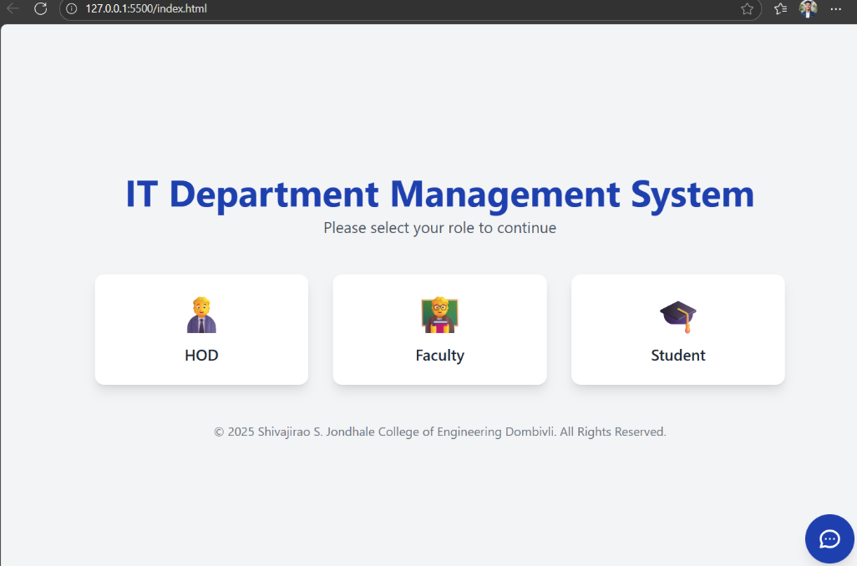

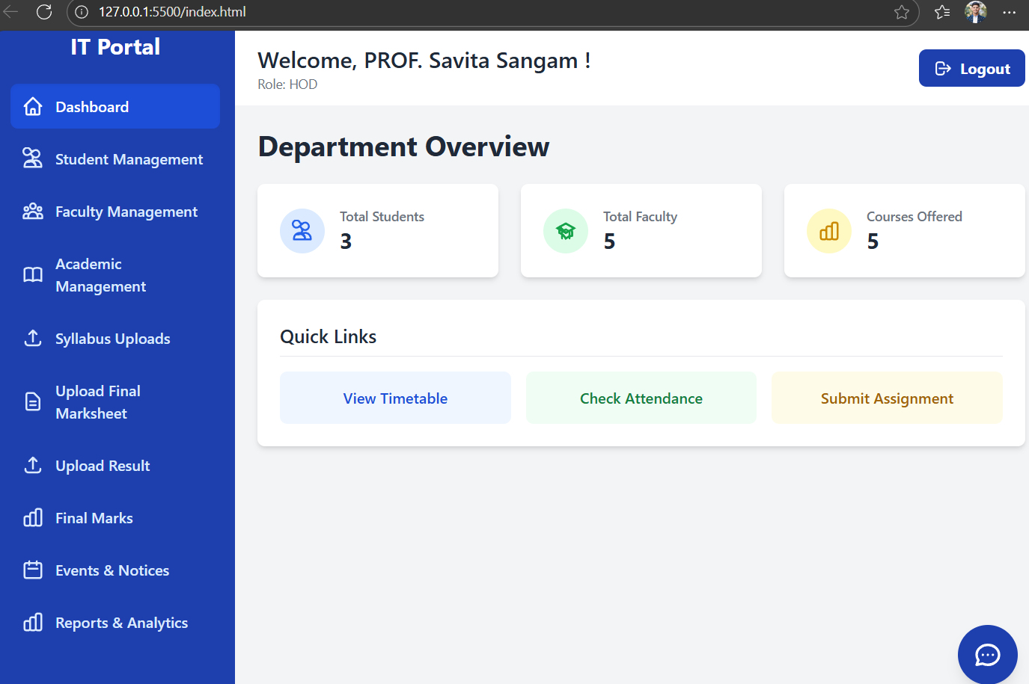

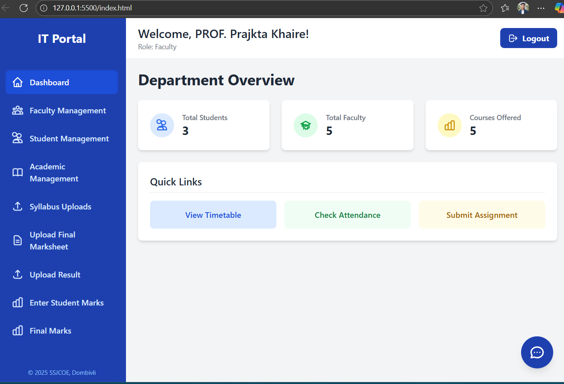

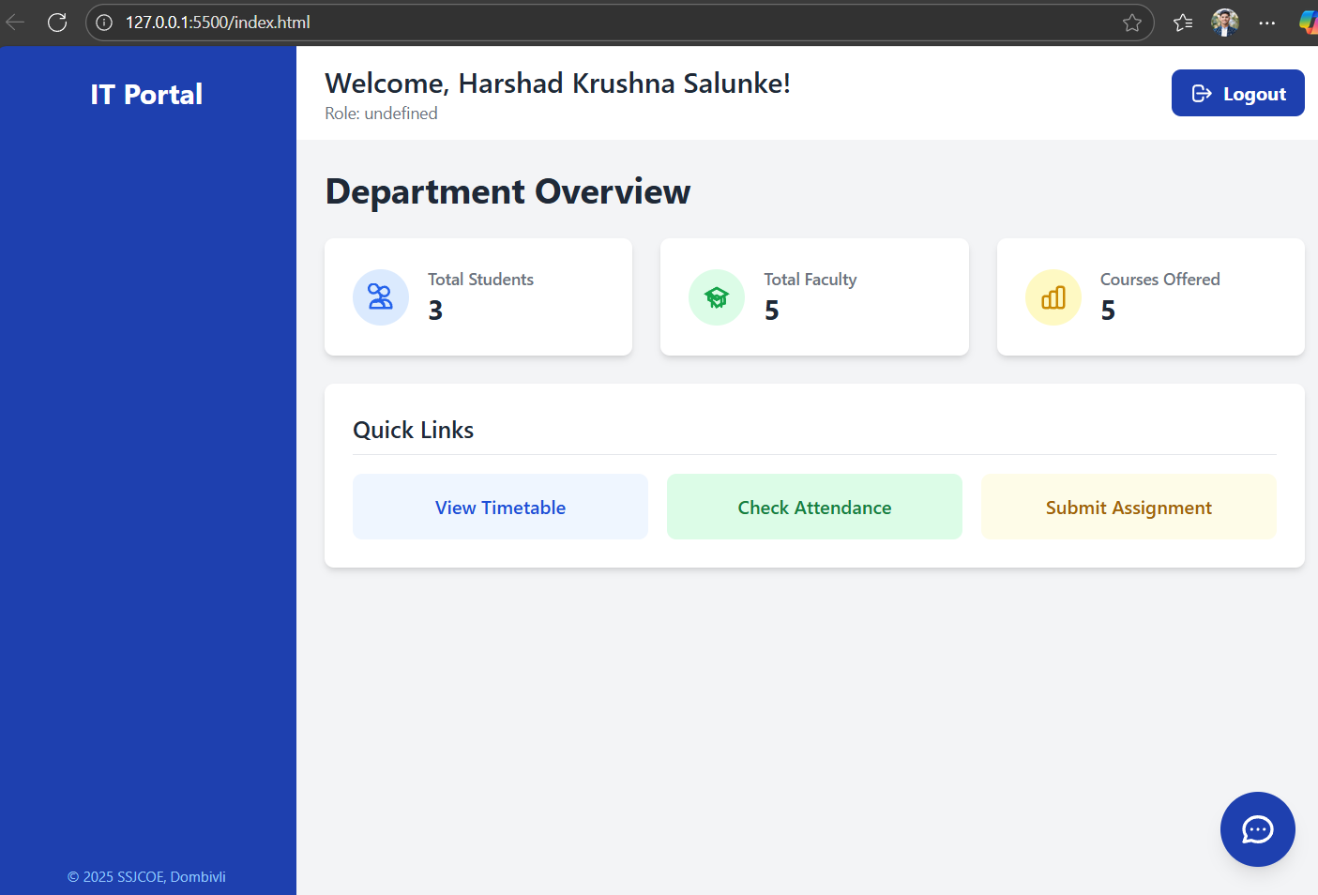

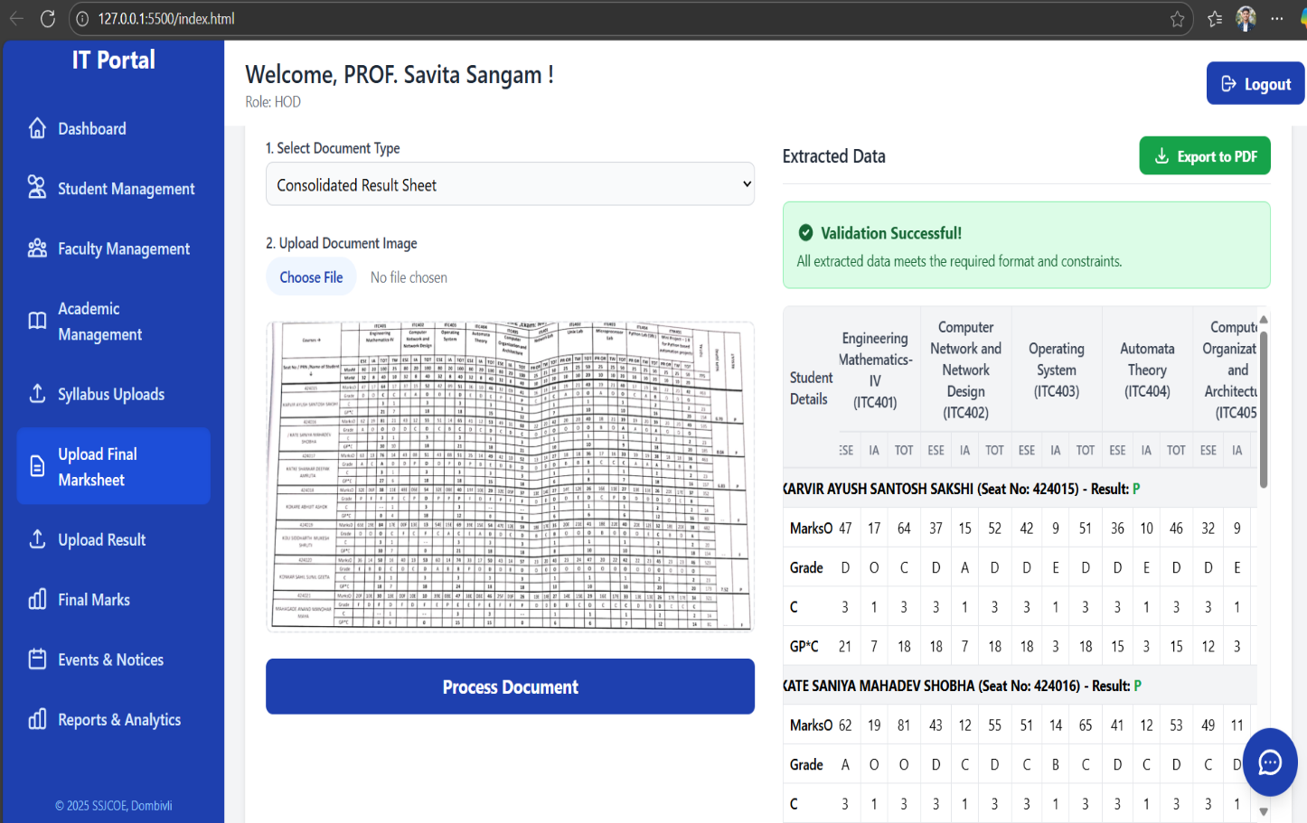

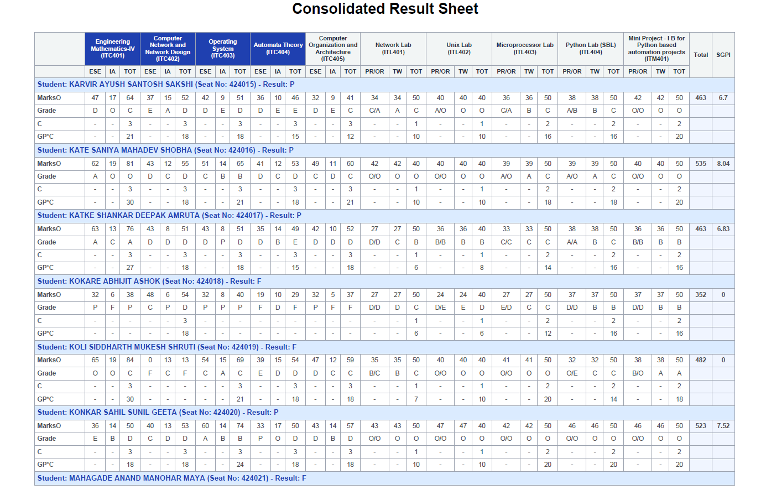

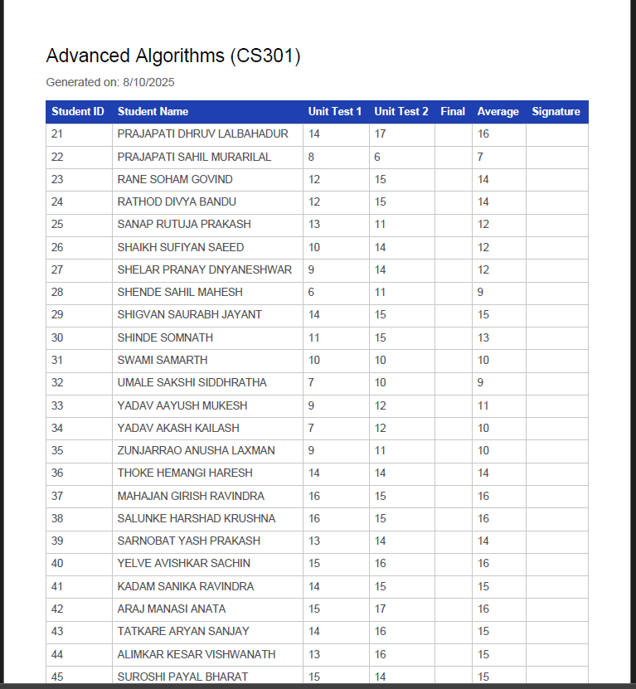

CONCLUSION AND FUTURE SCOPE:-

Conclusion

The IT Department Management System plays a crucial role in improving the efficiency, transparency, and coordination of departmental activities within an educational institution. The project successfully integrates various modules such as faculty, student, and HOD management, complaint handling, asset tracking, and report generation into a single digital platform. By automating routine administrative and technical processes, the system reduces manual workload, minimizes errors, and ensures accurate data management. It also enhances communication between faculty, students, and the department head through real-time information sharing and centralized data access.

Through this system, daily departmental operations become faster, more organized, and easier to monitor. The use of technology in managing IT-related tasks not only saves time but also improves accountability and decision-making. Although the current system meets essential departmental requirements, it also opens opportunities for future improvements, such as AI integration, mobile access, and IoT-based monitoring. In conclusion, the IT Department Management System provides a strong foundation for building a smarter, automated, and more efficient digital environment within the institution.

Future Scope

.
The future scope of the IT Department Management System is vast, as technology in education and IT management continues to evolve rapidly. In the coming years, the system can be enhanced with advanced automation and artificial intelligence (AI) to make departmental tasks more efficient and intelligent. AI-based chatbots can be integrated to assist students and faculty in resolving common IT issues, while machine learning algorithms can predict system failures, analyze complaint trends, and suggest preventive maintenance for IT equipment. The system can also be upgraded to include cloud-based storage and processing, allowing users to access the platform from anywhere securely and ensuring data backup and recovery in case of technical failures.

Future versions can include mobile applications for students, faculty, and technicians to manage activities on the go, such as submitting complaints, checking timetables, and updating maintenance tasks in real-time. The integration of Internet of Things (IoT) devices can further improve the monitoring of IT assets such as computers, projectors, and network devices, automatically detecting faults and usage patterns. The system can also connect with biometric attendance systems, ERP, and Learning Management Systems (LMS) to provide a unified digital ecosystem for the institution.

REFERENCES

- https://www.researchgate.net/publication/346208202_DEPARTMENT_MANAGEMENT_SYSTEM_-_WEB-BASED_APPLICATION

- https://www.scribd.com/document/735909758/A-Web-Based-Department-Management-System-for-Academic-Institutions

- https://www.w3schools.com/howto/default_page5.asp

- https://www.researchgate.net/publication/348929524_DEPARTMENT_INFORMATION_MANAGEMENT_SYSTEM

